[Insert Date]
Hello [Insert Teacher’s Name & Grade] Class Families!
Can you believe it’s already the first day of May, and we are about to have [insert grade #] graders? I can’t!!! The end of the year is quickly approaching, and I wanted to get some important info out to each of you!
Teacher Appreciation Week is here! ([insert dates]). We want to show [Insert Teacher’s Name] how much we appreciate all she does for our kiddos. Each day is a special theme to show her how much we truly do appreciate her! While this week is teacher appreciation week, we also want to show our appreciation to our Specials Teachers (Art, Music, PE, and Library), and Special Education Teachers, Paraprofessionals and Administrators. It takes a village and our village at BWE is special!
Teacher Appreciation Week [Below is an example only]
Monday, May 4th – Wear Your Teacher’s Favorite Color 🎨
Kick off the week in style! Show your appreciation by wearing your favorite teacher’s favorite color. Let’s fill the school with a rainbow of gratitude!
Tuesday, May 5th – Notes & Doodles of Thanks 💌
Get creative! Write a heartfelt note or draw a special picture for your favorite teacher to let them know how much they mean to you.
Wednesday, May 6th – Snack Attack! 🍪
Treat your teacher to something tasty! Bring their favorite sweet or salty snack to brighten their day and keep them energized.
Thursday, May 7th – Supply Surprise ✏️
Help stock the classroom! Bring your teacher their favorite school supply—whether it’s colorful pens, sticky notes, or anything they love to use.
Friday, May 8th – Favorite Things Finale 🎁
End the week with a smile! Choose something from your teacher’s “favorite things” list and give a small gift to show your appreciation.
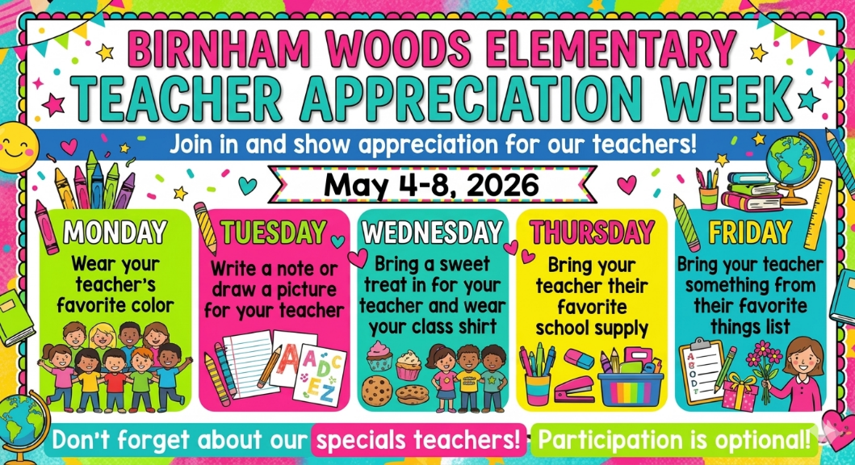

The end of the year is just around the corner! I thought it would be nice to coordinate an end-of-year class gift for [Insert Teacher’s Name] to show our appreciation. Again, this is completely optional, so please do not feel like you have to participate. If you would like to give, please send your monetary contributions via PayPal (friends and family so they don’t take out fees) or Venmo to [Insert Venmo account information] and in the notes section please say “[insert teacher’s name] end of year gift.” I have also attached an envelope with my name on it where you may put your contribution in and return with your child to school. The teacher will then send it to us! We will put a class gift together for [insert teacher’s name] (gift card from her favorites list)! We will give [insert teacher’s name] the gift from the class at the end of year awards/celebration on [insert date/time] after the [insert grade #] grade awards ceremony at 9am.
Please let us know if you have any questions. If you would like to send your contribution via PayPal or Venmo you can do so via my email: [insert email address] please put a note saying it’s for “End of Year [insert teacher’s name]”- Thank you!
Please send in your contribution by [insert due date]. This will give us some time to get it all put together and ready for the end of year awards/party day on [insert date]. All are welcome to attend the End of Year Awards Celebration at 9am followed by a celebration in the classroom with the class.
Please see link to find teacher/staff Favorites! ([insert teacher’s name] is shown below in the graphic)
BWE Teacher and Staff Favorites: https://bwepto.org/teacher-favorites/
Thank you all so much,
[insert teacher’s name] Class Homeroom Parents
[Insert name/phone number/email address for all room parents]

