Friday, May 2, 2025
Hello [Insert Teacher Name] [Insert Grade Level #] Grade Class Families!
Can you believe it’s already the first day of May, and we are about to have [Insert next year grade level] graders? We can’t!!! The end of the year is quickly approaching, and we wanted to get some important info out to each of you!
Teacher Appreciation Week is here! (May 5th – 9th). We want to show [Insert Teacher Name] how much we appreciate all she does for our kiddos. Each day has a suggested gift to show her how much we truly do appreciate her! While this week is teacher appreciation week, we also want to show our appreciation to our Specials Teachers (Art, Music, PE, and Library), and Special Education Teachers, Paraprofessionals and Administrators. It takes a village and our village at BWE is special! Participation in Teacher Appreciation Week is completely optional.
Teacher Appreciation Week
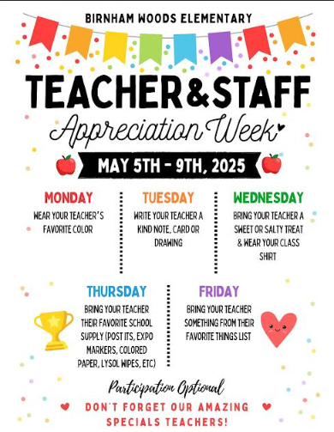
Monday, May 5th– Wear your teacher’s favorite color! [Insert Teacher Name] favorite colors are [Insert teacher’s favorite colors].
Tuesday, May 6th – Write your teacher a kind note, card or drawing! Get your creative juices flowing and spread the love with your kind words or beautiful designs.
Wednesday, May 7th -- Bring your teacher a sweet or salty treat & wear your class shirt! Choose a sweet/salty/snack off your teacher favorites list to surprise them with! These little “pick-me ups” sometimes bring the biggest smiles to their faces! Some of [Insert Teacher Name] favorite snacks are: [Insert Teacher’s Favorite Snacks].
Thursday, May 8th—Bring your teacher’s favorite school supply (post-its, expo markers, colored paper, Lysol wypes, etc.)! Help restock the teacher’s school supplies with some of their favorites. [Insert Teacher Name] loves [Insert Teacher’s Favorite School Supplies].
Friday, May 9th – Bring your teacher an item from their favorites list! Each teacher filled out a favorite things sheet at the beginning of the year with their favorite places to shop, favorite sweets, favorite restaurants, colors, etc. For families wishing to give a small gift or gift card to their teacher(s)—gifts can be given individually.
[Insert Teacher Name] Favorites List can be found here: [Insert link to Teacher’s Favorite’s List]

End of Year Information
The end of the year is just around the corner! We thought it would be nice to coordinate an end-of-year class gift for [Insert Teacher Name] to show our appreciation. Again, this is completely optional, so please do not feel like you have to participate. If you would like to give, please send your monetary contributions via PayPal (friends and family so they don’t take out fees) or Venmo to [Insert Venmo name] and in the notes section please say “[Insert Teacher Name]’s end of year gift.” We have also attached an envelope with my name on it where you may put your contribution in and return with your child to school. The teacher will then send it to us! We will put a class gift together for [Insert Teacher Name] (gift card from her favorites list)! We will give [Insert Teacher Name] the gift from the class at the end of year awards/celebration on [Insert date of ceremony] after the [Insert grade level] awards ceremony at 9am.
Please let us know if you have any questions. If you would like to send your contribution via PayPal or Venmo you can do so via my email: [insert account information] please put a note saying it’s for “End of Year [Insert Teacher Name]”- Thank you!
Please send in your contribution by Thursday, May 15th. This will give us some time to get it all put together and ready for the end of year awards/party day on [Insert date of ceremony]. All are welcome to attend the End of Year Awards Celebration at 9am followed by a celebration in the classroom with the class.
BWE Teacher and Staff Favorites: https://bwepto.org/teacher-favorites/
Thank you all so much,
[Insert Room Parent Name, Email Address and Phone Number]
[Insert Teacher Name] Class Homeroom Moms

