Hey [teacher name] [insert grade level] Grade Families!!
My name is [insert name] ([insert kids name] mom). We are so excited to be room parents this year for [insert teacher’s name] [insert grade level] Grade class! Our year is off to a great start and hope yours is too!
As different events come up this year and we are given direction as to how the school is going to handle volunteers, and guests we will let each of you know. Our goal is to try our very best to make special events happen while keeping everyone safe and following the district set safety guidelines.

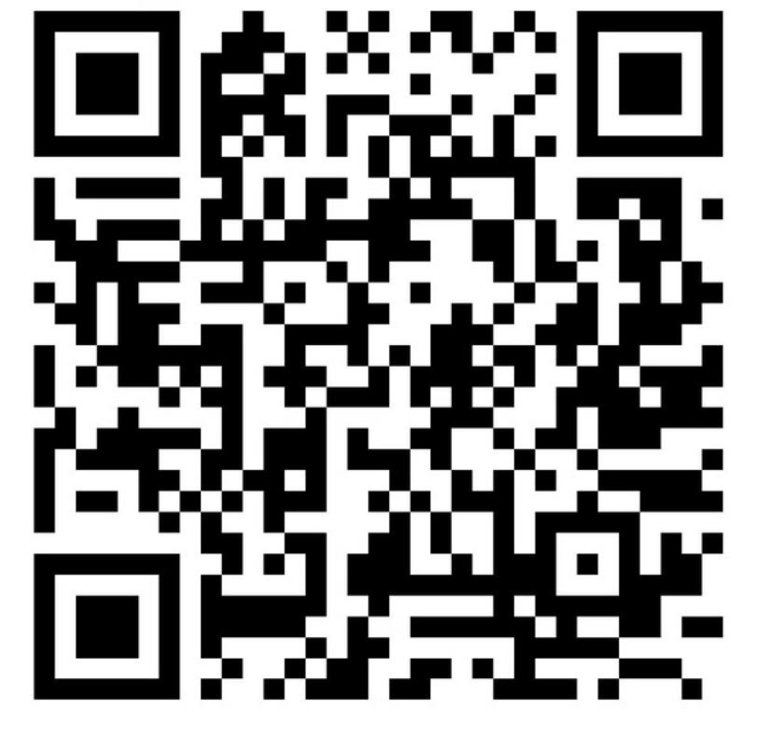
I would love for each of you to fill out this google form by scanning the QR code or by visiting https://bwepto.org/parent-contact-information-form/. By filling out this form (one per student that you have at BWE) this will allow us, your child’s room parents, to have your contact info so that we can be in contact with each of the families in our class. I will set up a “GroupMe” (message app) and invite each of you to it with the info you provide. This is a great way to stay connected as a class, be able to support and ask class relevant questions, and share pictures and info as it comes up during the school year. If you choose not to join the GroupMe, but still want to be involved and get info about volunteer opportunities, please email me so that I can share that info with you too.

If you have any questions anytime, please don’t hesitate to ask. We are here to help our amazing [insert teacher name], and our amazing [insert grade] graders!

PS. On the back side of this letter is [insert teacher’s name] Favorite Things! This is a great thing to keep handy!

Thank you so much,
[insert room parent name(s)]

[insert room parent name]
[insert room parent phone number]
[insert room parent

